Model1:

Task 2

The best growth rate is 0.50 when we fix rate of lighting equals 0.06 after iterate 100000 steps and the average number of trees survived is 9.70096

Task 3

Given the fix rate of lighting, the number of trees survived increase from growth rate equals 0.05 to 0.50. It reach peaks when the growth rate equals 0.5. then it decreases although lighting rate increases. The chart is almost symmetric. Because the tree which catches fire and the flame will spread to all contiguous trees. So high growth rate may have more contiguous trees group which makes the number of trees survived much lower.

The real-world phenomenon is Amazon rainforest wildfires. There are 6.7 million km2

of Amazon rainforest and the density is an important measure of rainforest. When fire happens , higher density may has more contiguous trees and the number of trees survived will lower than lower density area. Here density of forests can analogy with the growth rate. When the density is low, the number of trees survived is small but when the density increases, it will increase until reaches a peak. Then it will decrease due to large number of contiguous trees group.

Model 2 :

Task 2

Assume the agent whose followers great than neighbourhood in its local radius is an influencer who will lead to a trend. It is the most crowded spot in its followers visible radius and they will move toward and link to it. First, We define an agent set contains all the influencers.

set local-neighborhood count (other turtles) in-radius local-radius

set trends turtles with [count my-in-links > local-neighborhood]

The monitor and this plot show the number of current and history trends

Other plots show the current influencers location and the number of their corresponding followers. The number on the legends are their turtle numbers. Those plots show the diversity of ongoing fashion trends. The strength of each fashion trend can be quantified as each influencer’s location and the number of followers.

Meanwhile, those plots show the distribution of agent’s status. Red colour means agent are in high status and green colour means agent are in low status

All the plots above represent the status in the below screenshot and they are real time measurements which can display in the model.

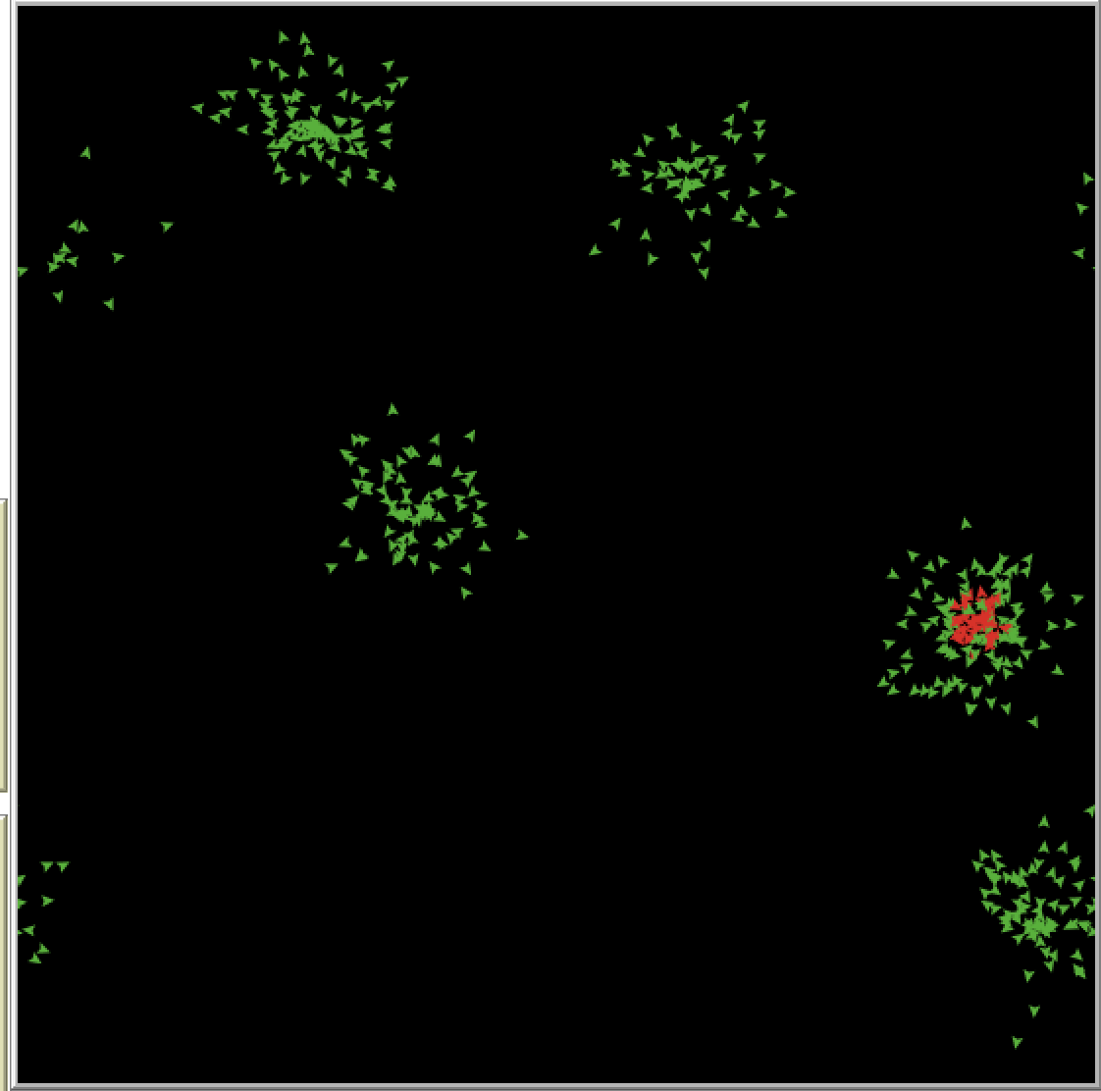

Overall, the plots and a monitor capture the essence of fashion and visualize those ongoing fashion trends in real time. However, this model doesn’t consider the attitude and relationship within each agents. One of the future improvement could be when agent becomes an influencer , other agents may have different attitude with it and their action will be based on their attitude. When the number of agents who have different attitude increases, it may also slightly change the attitude of the rest.